Live Q&A 3 Transcript






ty josh

Preliminaries
Please fill out the quiz!!
Exercise sheet 1 solutions now available on KEATS
The week 2 quiz is due at 5pm BST today
Week 3 quiz not recognising correct answers in reasonable format
- Answers with leading with 0s
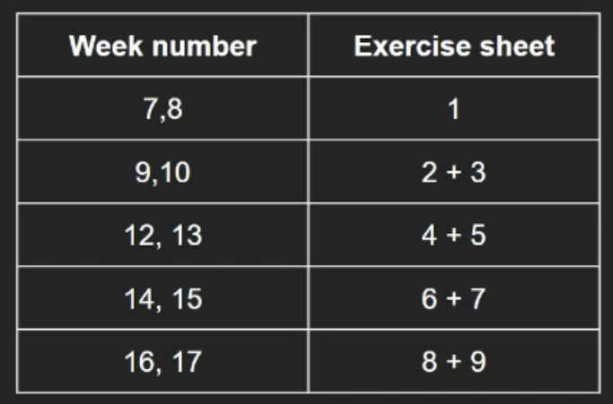

PollEv and Questions and Answers

In two’s complement, are 11111001 and 1001 equivalent?
Both of these two’s complement numbers represent the same numerical value.
Even though 1001 is a simpler format to understand as a human, if a computer says we use 8 bits, then 11111001 is the format we need to store in. In that way, these two are not the same.
For a given number of bits, there is only one representation for a specific value.
We said that having multiple of representations of 0 is a disadvantage. So is it a disadvantage of two’s complement that there are multiple representations of the same numeric value? Probably not. Similar to 5, 05, 0005 in decimal.

Is overflow a problem?
Depends on the context. What computer system are you using? What constitutes a problem?
You can see ideas of overflow being a real problem in the optional material this week.
What do you do if you identify an overflow in an exam? Just increase the number of bits.

Detecting overflow in two’s complement
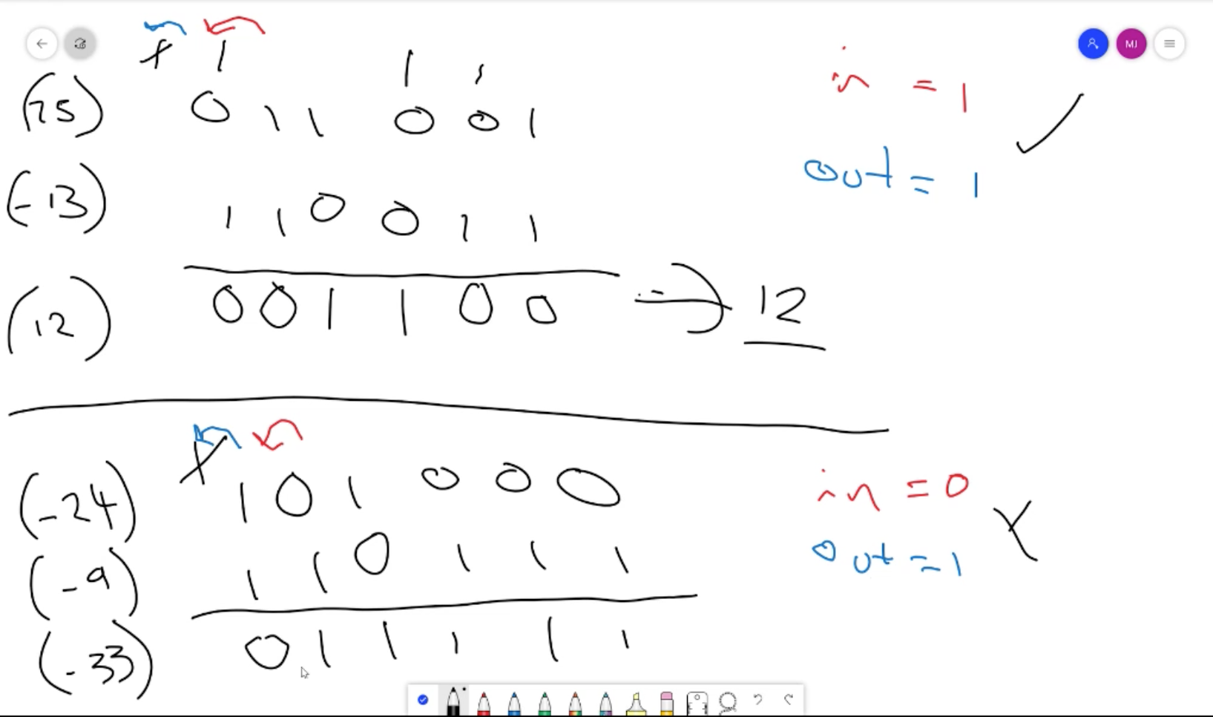
Carry-in and carry-out should be equal.

If you’re expecting a negative value and the overflow makes it so the most significant bit is positive, then there is something wrong.

Live Q&A

001101 + 00100 (two’s complement)
I’m happy to work through these specific examples. Looking at this one, I can’t see why this one can be complicated.

Rella is precious
I agree. Thank you!

Thank you for blessing our day with your dog
You’re welcome!

Do you have any tips for waking up and staying conscious for morning tutorials
Coffee! A bit more seriously, get to bed early. It’s very easy to get distracted

Is there a rule to detect overflow in one’s complement?
I’m not aware of an easy way to detect overflow in one’s complement. However, there’s a way we can work through it.
Positive + positive will give a positive number. Negative + negative will always give a negative number. If you get any answer, then there is an overflow.
Overflow is only going to occur beyond the most positive or most negative values we can represent, so positive + negative doesn’t have to be checked.

Can we see your dog every week?
She’s normally sleeping at this time. If she’s ever out and about, sure!

Are we expected to go through the current week’s content before attending the LGT/SGT for that week?
Yes. You have enough time before, as the LGT falls

Chris Evans has a dog too
You guys are obsessed with Chris Evans

Who’s Rella’s favourite?
Me!

What happened to your graphic tablet?
It may not look like it, but I’m using it. I just need more practice.

So can all computers use all types of negative binary or do some only store negatives in two’s complement, some only store negative in one’s complement and some only store it in signed binary?
Next week, we’re going to cover the format general computers use. Typically we use IEEE-754.

Will we need to understand how to deal with overflow for all types of binary?
Yes.

Why don’t you hide the questions you already answered?
Oh! I didn’t know that was a feature. Thank you for that!

How do we multiply 11011 x 11011?
I recommend you go back and review the videos on multiplication

If it’s 1+1+1+1, will the answer be 0, carry the “1” 2 times?
Yes, but when computers do addition, they only ever add two numbers, unless there is

Do you know if the teaching and revision week at the end of the semester will be online only or hybrid?
Sorry, I don’t know the answer.

